

Name :Minahil Qadir
Roll number: su92-bsaim-s24-047
Program:BSAI
Submitted to :Proff Rasikh Ali
Project : Events and Concert ticketing Chatbot

Objective:
To develop a chatbot that helps users:
- View upcoming concerts and events
- Check ticket availability
- Book tickets interactively
- Communicate naturally using text

Tools and Technologies
- Python – Programming language
- NLTK (Natural Language Toolkit) – For NLP and pattern matching
- Regex (Regular Expressions) – For matching user input
- Dictionary – To store events and tickets

System Description
The chatbot consists of two main parts:
NLP Chat System – Handles greetings, general questions, and simple conversations.
Ticket Booking System – Handles checking tickets, booking, and confirming orders.

Data Structure
Events are stored in a Python dictionary:
- Key: Event name
- Value: Dictionary with date, venue, and tickets

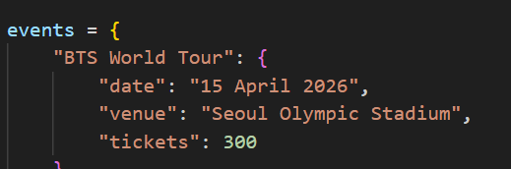

Features
- Displays all upcoming concerts with date and venue
- Checks remaining ticket availability
- Step-by-step ticket booking
- Updates ticket count dynamically
- Handles greetings, thanks, and exit commands

Working Flow
Chatbot greets the user
User can ask to show events or check tickets
If booking, chatbot asks:
  - Event name
  - Number of tickets
  - User name
Confirms booking and shows details
Tickets are reduced automatically
User can exit anytime

Input Examples
- Greetings: "Hi", "Hello"
- Show events: "Show events"
- Check tickets: "Tickets for BTS World Tour"
- Start booking: "Book tickets"
- Event name: "BTS World Tour"
- Number of tickets: "2"
- Name: "Mahi"
- Exit: "Bye", "Exit"
Output Example

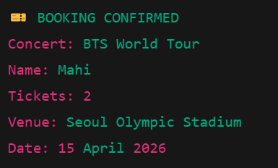

Error Handling
- If the user enters an invalid event, chatbot asks to re-enter

THANKYOU😊

